**PROJECT REPORT**

**ON**

**COMPLAINT MANAGEMENT SYSTEM**

**USING**

**JAVA**



**UNIVERSITY INSTITUTE OF ENGINEERING AND TECHNOLOGY,PU,CHD**

**SUBMITTED TO: SUBMITTED BY :**

Diksha Jindal( UE143031)

Gunjan Aggarwal (UE143036)

Harmanpreet Kaur (UE143039)

CSE(4th year)

**INDEX**

## TABLE OF CONTENTS PAGE NO.



* Introduction and objective 2-4
* Feasibility analysis 5
* System requirement specification 6
* SDLC 7
* Introduction to front end application 8-11
* Introduction to back end application 12-15
* DFD 16
* E-R DIAGRAM 17-18
* Data structures and database specification 19-21
* Design 22-30
* Testing 31-33
* Conclusion and Bibliography 34

INTRODUCTION

Complaint Management System provides services for arrived complaint of people. It is basically designed for Telecommunication companies like BSNL. So customers can register their complaints, can view the status of their complaints, give feedback depending on the service. All the complaints arrived from the people are distributed to different departments according to Complaint category. Then the corresponding employees can solve the issues regarding the customers. Apart from that reports are also generated which includes total number of reports in every month that are handled, number of reports handled by every employee and performance of every employee regarding how many complaints he has successfully solved and depending on his feedback.

## OBJECTIVE OF THE PROJECT

An effective complaints management system is integral to providing quality customer service. It

helps to measure customer satisfaction and is a useful source of information and feedback for improving services. Often customers are the first to identify when things are not working properly.

Implementing effective complaints management systems within public sector agencies:

•         Improves Companies internal complaints handling

•         Reduces recurring complaints

•         Improves standards of service to the community

•         Raises standards of administrative decision-making

The following objectives have been set:

1) Smooth flow of data without any hurdles.

2) Adequate validation checks for data entry.

3) Adequate security of data.

4) Facility to update data from time to time.

5) Prompt and specific retrieval of data.

6) Flexibility in the system according to the changing environment.

7) Controlling redundancy in storing the same data multiple times.

8) Accuracy, timeliness and comprehensiveness of the system output.

9) Stability and operability by people of average intelligence.

10) Enhancement in the completion of work within the constraints of time

FEASIBILITY ANALYSIS

Depending on the results of the initial investigation, the survey is expanded to a more detailed feasibility

study. A feasibility study is a test of a system proposal. According to its workability, impact on the

organization, ability to meet user’s needs and effective use of the resources its main task done during the

feasibility study are:-

1. Evaluation of existing system and procedures. Our group went to various Professionals to gather information about the software system. They are using and evaluating those system and the procedures invoked in it during the period of feasibility study.
2. Analysis of alternative candidate systems after studying the various systems we derived various alternatives through which we develop our project and evaluated the alternative. The most appropriate is selected.

FEASIBILITY STUDY :

The only tangible benefit provided by the proposed system is that the paper work is reduced to the minimum and hence the reduction in cost incurred on Stationary and its storage. The system provides many benefits that can’t be measured in terms of Money for e.g. user’s friendliness, more user response being more efficient.

* + TECHNICAL FEASIBILITY:-

The proposed system is technically feasible as it can be developed easily with the help of available technology. The proposed system requires NETBEANS as interface using JAVA for backend and MYSQL for database connectivity.

* + OPERATIONAL FEASIBILITY:-

Automation makes our life easy. The proposed system is highly user friendly and is much easily able to interact with the system. Therefore the users will readily accept the system as data entry and making queries can be easily done.

**SYSYTEM REQUIREMENTS**

Hardware specifications

Hardware is a set of physical components, which performs the functions of applying appropriate, predefined instructions. In other words, one can say that electronic and mechanical parts of computer constitute hardware.

This package is designed on a powerful programming language Netbeans. It is a powerful Graphical User Interface. The backend is MYSQL which is used to maintain database. It can run on almost all the popular microcomputers. The following are the minimum hardware specifications to run this package: -

Personal Computer: -

It minimum contains P-III

Processor with 128 MB RAM

Software Requirements**:**

The software is a set of procedures of coded information or a program which when fed into the computer hardware, enables the computer to perform the various tasks. Software is like a current inside the wire, which cannot be seen but its effect can be felt.

1. Operating System:- Windows NT / 2000 / XP

2.Application Software:- Application software uses front end Netbeans that uses Java IDE and Mysql Database that uses Sql Language.

**SOFTWARE DEVELOPMENT LIFE CYCLE**

A system development life cycle is a logical process by which system analysts, software engineers, programmers, and end users build information systems and computer applications to solve business problems and needs.

The major phases involved in the MIS development process are referred to as system development life cycle. Each phase of the development process must have well defined objectives ,and at the end of each phase ,progress towards meeting the objectives must be evaluated.

The development process should not continue until the objectives of all prior phases have been met.

System development life cycle is a phased approach to analysis and design to ensure that systems are best developed.

The system development life cycle can be divided into seven phases as shown in fig

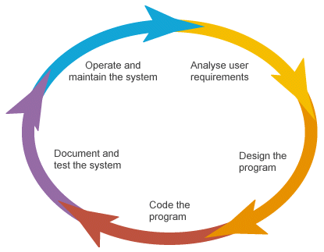

**INTRODUCTION TO FRONT END**

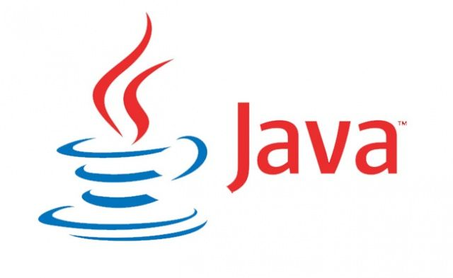

INTRODUCTION

**Java** is a set of several [computer software](https://en.wikipedia.org/wiki/Computer_software) and specifications developed by [Sun Microsystems](https://en.wikipedia.org/wiki/Sun_Microsystems), later acquired by [Oracle Corporation](https://en.wikipedia.org/wiki/Oracle_Corporation), that provides a system for developing [application software](https://en.wikipedia.org/wiki/Application_software) and deploying it in a [cross-platform](https://en.wikipedia.org/wiki/Cross-platform) computing environment. Java is used in a wide variety of [computing platforms](https://en.wikipedia.org/wiki/Computing_platform) from [embedded devices](https://en.wikipedia.org/wiki/Embedded_device) and [mobile phones](https://en.wikipedia.org/wiki/Mobile_phone) to [enterprise servers](https://en.wikipedia.org/wiki/Enterprise_server) and [supercomputers](https://en.wikipedia.org/wiki/Supercomputer). While less common, [Java applets](https://en.wikipedia.org/wiki/Java_applet) run in secure, [sandboxed](https://en.wikipedia.org/wiki/Sandbox_(computer_security)) environments to provide many features of native applications and can be embedded in HTML pages.

In the [Java programming language](https://en.wikipedia.org/wiki/Java_(programming_language)) is the primary way to produce code that will be deployed as [byte code](https://en.wikipedia.org/wiki/Java_byte_code) in a [Java Virtual Machine](https://en.wikipedia.org/wiki/Java_Virtual_Machine) (JVM); byte code [compilers](https://en.wikipedia.org/wiki/Compiler) are also available for other languages, including [Ada](https://en.wikipedia.org/wiki/Ada_(programming_language)" \o "Ada (programming language)) , [JavaScript](https://en.wikipedia.org/wiki/JavaScript), [Python](https://en.wikipedia.org/wiki/Python_(programming_language)), and [Ruby](https://en.wikipedia.org/wiki/Ruby_(programming_language)). In addition, several languages have been designed to run natively on the JVM, including [Scala](https://en.wikipedia.org/wiki/Scala_(programming_language)" \o "Scala (programming language)), [Clojure](https://en.wikipedia.org/wiki/Clojure" \o "Clojure) and [Groovy](https://en.wikipedia.org/wiki/Groovy_(programming_language)). [Java syntax](https://en.wikipedia.org/wiki/Java_syntax) borrows heavily from [C](https://en.wikipedia.org/wiki/C_(programming_language)) and [C++](https://en.wikipedia.org/wiki/C%2B%2B), but object-oriented features are modeled after [Smalltalk](https://en.wikipedia.org/wiki/Smalltalk) and [Objective-C](https://en.wikipedia.org/wiki/Objective-C).[[11]](https://en.wikipedia.org/wiki/Java_(software_platform)#cite_note-11) Java eschews certain low-level constructs such as [pointers](https://en.wikipedia.org/wiki/Pointer_(computer_programming)) and has a very simple memory model where every object is [allocated on the heap](https://en.wikipedia.org/wiki/Dynamic_memory_allocation) and all variables of object types are [references](https://en.wikipedia.org/wiki/Reference_(computer_science)). Memory management is handled through integrated automatic [garbage collection](https://en.wikipedia.org/wiki/Garbage_collection_(computer_science)) performed by the JVM.

**PLATFORM**

The Java platform is suite of programs that facilitate developing and running programs written in the [Java](https://en.wikipedia.org/wiki/Java_(programming_language)) programming language. The platform is not specific to any one processor or [operating system](https://en.wikipedia.org/wiki/Operating_system), rather an execution engine (called a [virtual machine](https://en.wikipedia.org/wiki/Virtual_machine)) and a compiler with a set of libraries are implemented for various hardware and operating systems so that Java programs can run identically on all of them. There are multiple platforms, each targeting a different class of devices:

* [Java Card](https://en.wikipedia.org/wiki/Java_Card): A technology that allows small Java-based applications ([applets](https://en.wikipedia.org/wiki/Applet)) to be run securely on [smart cards](https://en.wikipedia.org/wiki/Smart_card) and similar small-memory devices.
* [Java ME](https://en.wikipedia.org/wiki/Java_ME) (Micro Edition): Specifies several different sets of libraries (known as profiles) for devices with limited storage, display, and power capacities. Often used to develop applications for mobile devices, PDAs, TV [set-top boxes](https://en.wikipedia.org/wiki/Set-top_boxes), and printers.
* [Java SE](https://en.wikipedia.org/wiki/Java_SE) (Standard Edition): For general-purpose use on desktop PCs, servers and similar devices.
* [Java EE](https://en.wikipedia.org/wiki/Java_EE) (Enterprise Edition): Java SE plus various APIs useful for [multi-tier](https://en.wikipedia.org/wiki/N-tier) [client–server](https://en.wikipedia.org/wiki/Client%E2%80%93server) [enterprise applications](https://en.wikipedia.org/wiki/Enterprise_application).

**JAVA VIRTUAL MACHINE**

The heart of the Java platform is the concept of a "virtual machine" that executes [Java bytecode](https://en.wikipedia.org/wiki/Java_bytecode) programs. This bytecode is the same no matter what hardware or operating system the program is running under. There is a JIT (Just In Time) compiler within the *Java Virtual Machine*, or JVM. The JIT compiler translates the Java bytecode into native processor instructions at run-time and caches the native code in memory during execution.

The use of bytecode as an intermediate language permits Java programs to run on any platform that has a virtual machine available. The use of a JIT compiler means that Java applications, after a short delay during loading and once they have "warmed up" by being all or mostly JIT-compiled, tend to run about as fast as native programs. Since JRE version 1.2, Sun's JVM implementation has included a [just-in-time compiler](https://en.wikipedia.org/wiki/Just-in-time_compilation) instead of an interpreter.

**CLASS LIBRARIES**

In most modern [operating systems](https://en.wikipedia.org/wiki/Operating_system) (OSs), a large body of reusable code is provided to simplify the programmer's job. This code is typically provided as a set of[dynamically loadable libraries](https://en.wikipedia.org/wiki/Library_(computer_science)#Dynamic_linking) that applications can call at runtime. Because the Java platform is not dependent on any specific operating system, applications cannot rely on any of the pre-existing OS libraries. Instead, the Java platform provides a comprehensive set of its own standard class libraries containing much of the same reusable functions commonly found in modern operating systems. Most of the system library is also written in Java. For instance, [Swing](https://en.wikipedia.org/wiki/Swing_(Java)) library paints the user interface and handles the events itself, eliminating many subtle differences between how different platforms handle even similar components.

**LANGUAGES**

The word "Java", alone, usually refers to Java programming language that was designed for use with the Java platform. Programming languages are typically outside of the scope of the phrase "platform", although the Java programming language was listed as a core part of the Java platform before Java 7. The language and runtime were therefore commonly considered a single unit. However, an effort was made with the Java 7 specification to more clearly treat the Java language and the Java virtual machine as separate entities, so that they are no longer considered a single unit.

Third parties have produced many [compilers](https://en.wikipedia.org/wiki/Compiler) or [interpreters](https://en.wikipedia.org/wiki/Interpreter_(computing)) that target the JVM. Some of these are for existing languages, while others are for extensions to the Java language. These include: [BeanShell](https://en.wikipedia.org/wiki/BeanShell) , [Clojure](https://en.wikipedia.org/wiki/Clojure) ,[Groovy](https://en.wikipedia.org/wiki/Groovy_(programming_language)), [JRuby](https://en.wikipedia.org/wiki/JRuby) ,[Jython](https://en.wikipedia.org/wiki/Jython" \o "Jython) ,[Kotlin](https://en.wikipedia.org/wiki/Kotlin_(programming_language)" \o "Kotlin (programming language)) ,[Rhino](https://en.wikipedia.org/wiki/Rhino_(JavaScript_engine)) ,[Scala](https://en.wikipedia.org/wiki/Scala_(programming_language)" \o "Scala (programming language)) ,[Gosu](https://en.wikipedia.org/wiki/Gosu_(programming_language)" \o "Gosu (programming language))

### Java Development Kit

The *Java Development Kit* (*JDK*) is a [Sun](https://en.wikipedia.org/wiki/Sun_Microsystems) product aimed at Java developers. Since the introduction of Java, it has been by far the most widely used Java [software development kit](https://en.wikipedia.org/wiki/Software_development_kit) (SDK)] It contains a Java compiler, a full copy of the [Java Runtime Environment](https://en.wikipedia.org/wiki/Java_Runtime_Environment) (JRE), and many other important development tools.

**NETBEANS**

**NetBeans** is a [software development](https://en.wikipedia.org/wiki/Software_development) platform written in [Java](https://en.wikipedia.org/wiki/Java_(programming_language)). The NetBeans [Platform](https://en.wikipedia.org/wiki/Platform_(computing)) allows applications to be developed from a set of modular [software components](https://en.wikipedia.org/wiki/Software_component) called *modules*. Applications based on the NetBeans Platform, including the NetBeans [integrated development environment](https://en.wikipedia.org/wiki/Integrated_development_environment) (IDE), can be extended by [third party developers](https://en.wikipedia.org/wiki/Third_party_developer).

NetBeans is [cross-platform](https://en.wikipedia.org/wiki/Cross-platform) and runs on [Microsoft Windows](https://en.wikipedia.org/wiki/Microsoft_Windows), [Mac OS X](https://en.wikipedia.org/wiki/Mac_OS_X), [Linux](https://en.wikipedia.org/wiki/Linux), [Solaris](https://en.wikipedia.org/wiki/Solaris_(operating_system)) and other platforms supporting a compatible [JVM](https://en.wikipedia.org/wiki/Java_Virtual_Machine).

**NETBEANS PLATFORM**

[Framework](https://en.wikipedia.org/wiki/Software_framework) for simplifying the development of [Java Swing](https://en.wikipedia.org/wiki/Java_Swing) desktop applications. The NetBeans IDE bundle for Java SE contains what is needed to start developing NetBeans plugins and NetBeans Platform based applications; no additional SDK is required.

Applications can install modules dynamically. Any application can include the Update Center module to allow users of the application to download [digitally signed](https://en.wikipedia.org/wiki/Digital_signature) upgrades and new features directly into the running application. Reinstalling an upgrade or a new release does not force users to download the entire application again.

The platform offers reusable services common to desktop applications, allowing developers to focus on the logic specific to their application. Among the features of the platform are:

* User interface management (e.g. menus and toolbars)
* User settings management
* Storage management (saving and loading any kind of data)
* Window management
* Wizard framework (supports step-by-step dialogs)
* NetBeans Visual Library
* Integrated development tools

NetBeans IDE is a free, open-source, cross-platform IDE with built-in-support for Java Programming Language.

**INTRODUCTION TO BACK END TOOL**

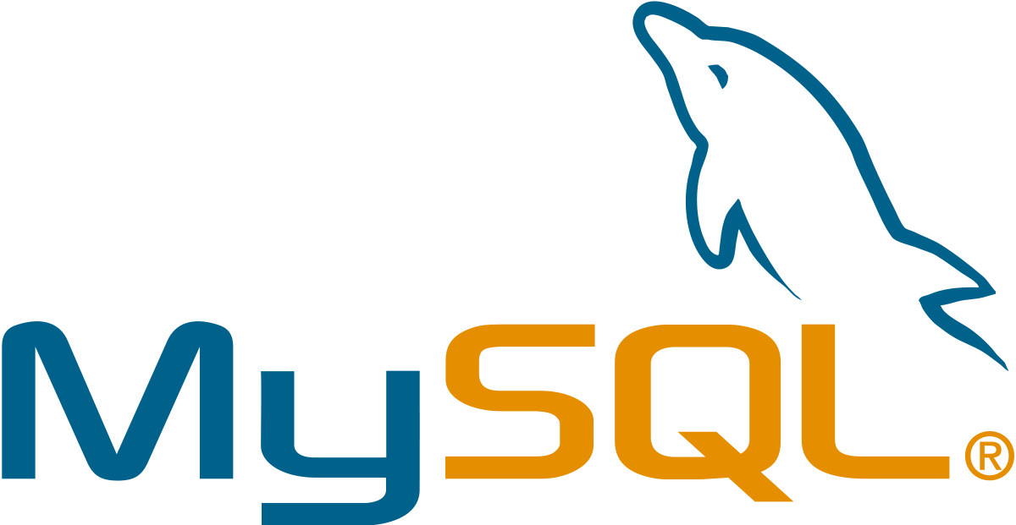

# Introduction to SQL: -

# SQL is a standard computer language for accessing and manipulating databases.

* SQL stands for **S**tructured **Q**uery **L**anguage.
* SQL allows you to access a database.
* SQL is an ANSI standard computer language.
* SQL can execute queries against a database.
* SQL can retrieve data from a database.
* SQL can insert new records in a database.
* SQL can delete records from a database.
* SQL can update records in a database.
* SQL is easy to learn.
* SQL is an ANSI (American National Standards Institute) standard computer language for accessing and manipulating database systems. SQL statements are used to retrieve and update data in a database. SQL works with database programs like MS Access, DB2, Informix, MS SQL Server, Oracle, Sybase, etc.
* Unfortunately, there are many different versions of the SQL language, but to be in compliance with the ANSI standard; they must support the same major keywords in a similar manner (such as SELECT, UPDATE, DELETE, INSERT, WHERE, and others).

## SQL Database Tables: -

A database most often contains one or more tables. Each table is identified by a name (e.g. "Customers" or "Orders"). Tables contain records (rows) with data.

**Below is an example of a table called "Persons": -**

|  |  |  |  |
| --- | --- | --- | --- |
| **Last Name** | **First Name** | **Address** | **City** |
| Hansen | Ola | Timoteivn 10 | Sandnes |
| Svendson | Tove | Borgvn 23 | Sandnes |
| Pettersen | Kari | Storgt 20 | Stavanger |

* The table above contains three records (one for each person) and four columns (Last Name, First Name, Address, and City).

## SQL Queries: -

With SQL, we can query a database and have a result set returned.

* **A query like this: -**

|  |
| --- |
| SELECT Last Name FROM Persons |

* **Gives a result set like this: -**

|  |
| --- |
| **Last Name** |
| Hansen |
| Svendson |
| Petersen |

**SQL Data Manipulation Language (DML)**

* SQL (Structured Query Language) is syntax for executing queries. But the SQL language also includes syntax to update, insert, and delete records.
* These query and update commands together form the Data Manipulation Language (DML) part of SQL:
* **SELECT** - extracts data from a database table
* **UPDATE** - updates data in a database table
* **DELETE** - deletes data from a database table
* **INSERT INTO** - inserts new data into a database table

## SQL Data Definition Language (DDL)

* The Data Definition Language (DDL) part of SQL permits database tables to be created or deleted. We can also define indexes (keys), specify links between tables, and impose constraints between database tables.
* **The most important DDL statements in SQL are: -**
* **CREATE TABLE** - creates a new database table
* **ALTER TABLE** - alters (changes) a database table
* **DROP TABLE** - deletes a database table
* **CREATE INDEX** - creates an index (search key)
* **DROP INDEX** - deletes an index MS SQL SERVER 2000

**SYSTEM DATA FLOW DIAGRAM**

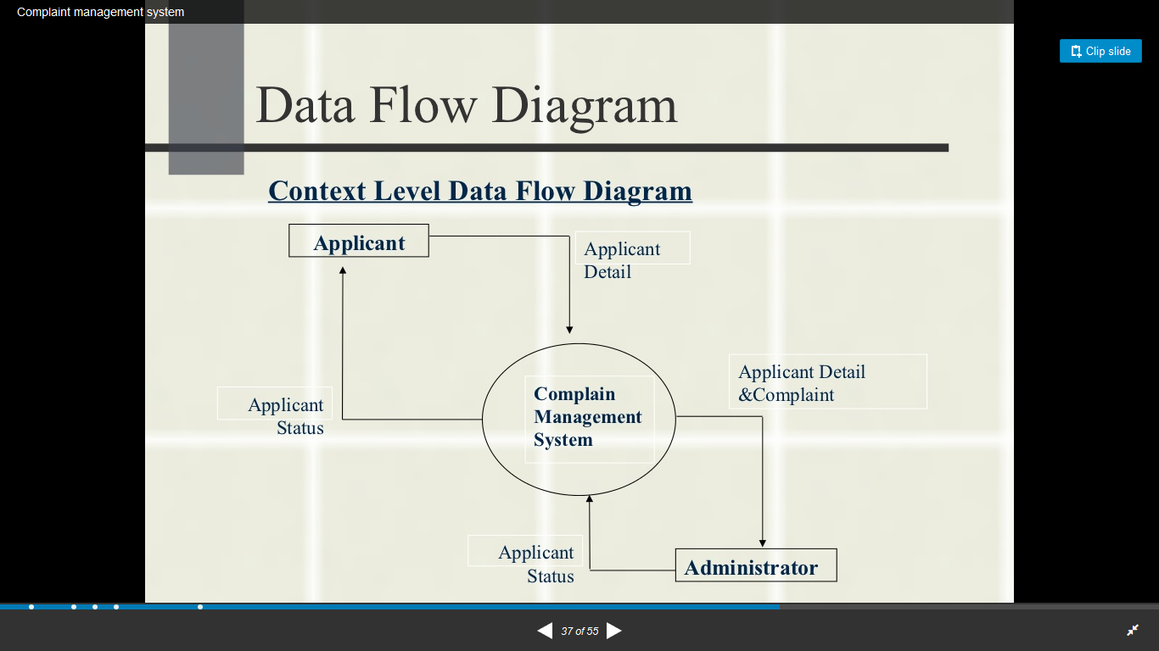

**E-R DIAGRAM**

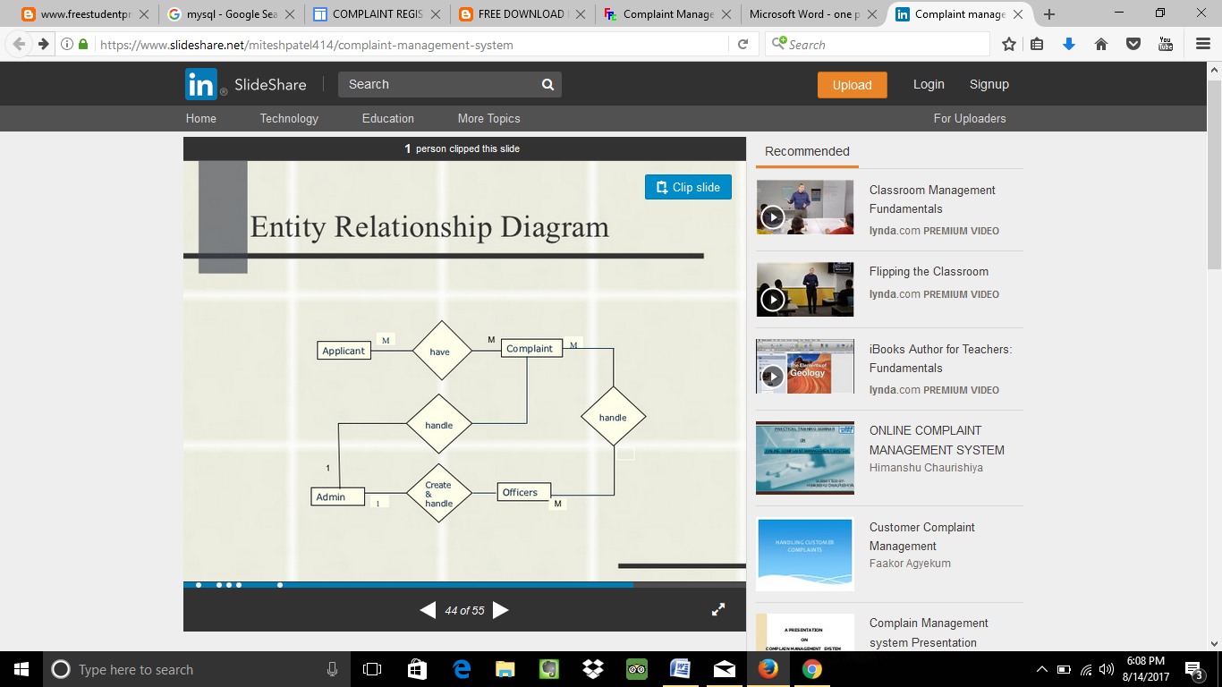

ER-modeling is a data modeling technique used in software engineering to produce a conceptual data model of a information system. Diagrams created using this ER-modeling technique are called Entity-Relationship Diagrams, or ER diagrams or ERDs. So you can say that Entity Relationship Diagrams illustrate the logical structure of databases.

Dr. Peter Chen is the originator of the Entity-Relationship Model. His original paper about ER-modeling is one of the most cited papers in the computer software field. Currently the ER model serves as the foundation of many system analysis and design methodologies, computer-aided software engineering (CASE) tools, and repository systems.

The original notation for ER-Diagrams uses rectangles to represent entities, and diamonds to represent relationships.

There are three basic elements in ER-Diagrams:

* Entities are the "things" for which we want to store information. An entity is a person, place, thing or event.
* Attributes are the data we want to collect for an entity.
* Relationships describe the relations between the entities.

ERDs show entities in a database and relationships between tables within that database. It is essential to have ER-Diagrams if you want to create a good database design. The diagrams help focus on how the database actually works.

Entity (Instance)

An instance of a physical object in the real world.

Entity Class

: Group of objects of the same type.

–

E.g. Entity Class “Student”, Entities “John”, “Trish” etc

Attributes

Properties of Entities that describe their characteristics.

Types:

Simple

: Attribute that is not divisible, e.g. age.

Composite

: Attribute composed of several simple attributes,

e.g. address (house number, street, district)

Multiple

: Attribute with a set of possible values for the same

entity, e.g. Phone (home, mobile etc.) or email

Key: Uniquely Ids the Entity e.g. PPSN, Chassis No.Each simple attribute associated with a VS that may be assigned to that attribute for each individual entity,

e.g. age = integer

**DATA STRUCTURES AND DATABASE SPECIFICATIONS**

**TABLE ACCOUNT**

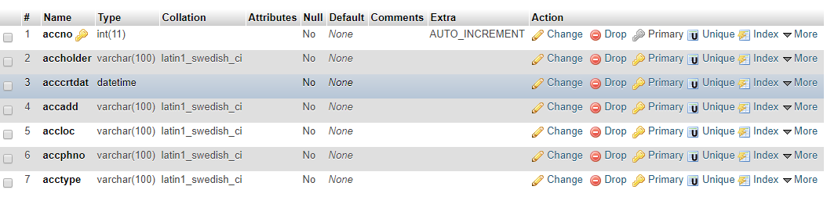

**TABLE COMPLAINT**

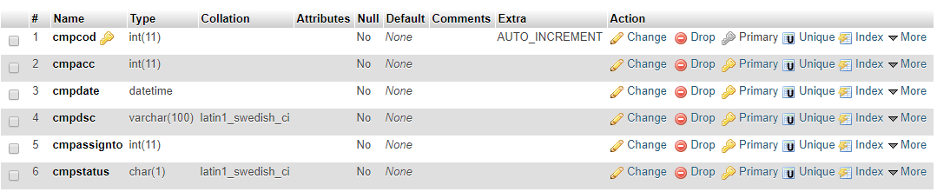

**TABLE EMPLOYEE**

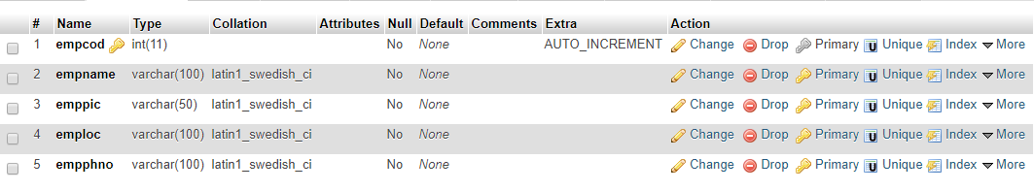

**TABLE VISITOR**

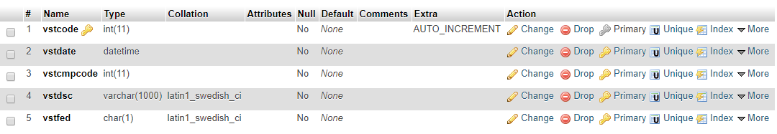

**STORED PROCEDURE**

For Table Accounts

1.Insertion Stored Procedure

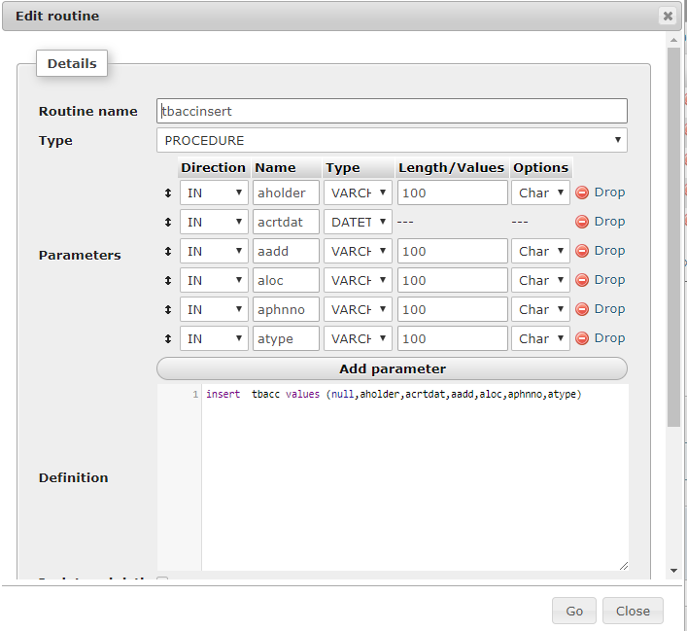

2.Update Stored Procedure

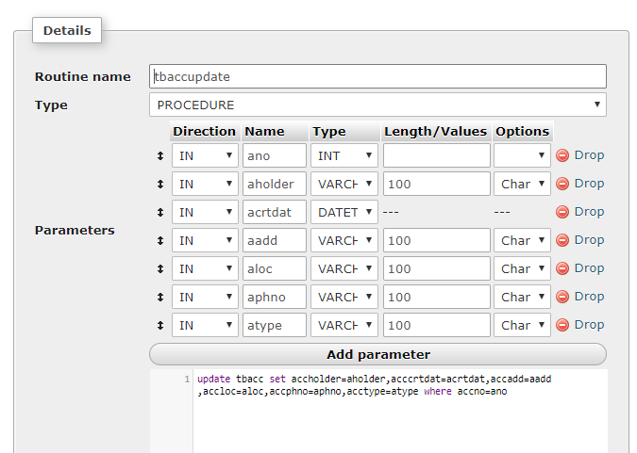

3.Delete Stored Procedure

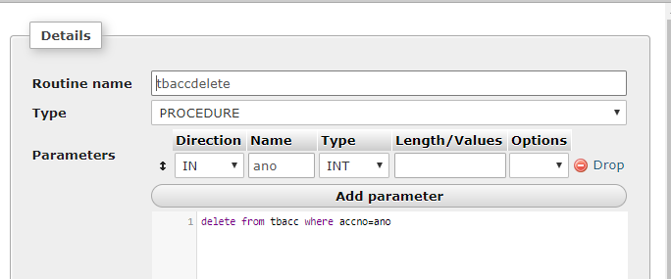

4.Display Stored Procedure

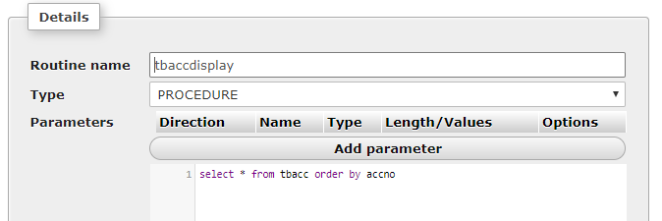

DESIGN

The Complaint Management System keeps the day by day tally record as a complete company..The project consists of the following modules -:

|  |  |
| --- | --- |
| SYSTEM MODULES | DESCRIPTION |
| 1. Login Module | A user can login with id and password. |
| 1. Open Account | New user can add account. |
| 1. Employee | Checks and add new employees database |
| 1. Register Complaint | A client can issue complaint |
| 1. Complaint Feedback | After issue is resolved client can give feedback depending on service |
| 1. Report Module | Reports are generated as Number of complaints handled in a month,performance of every employee etc. |

**EXISTING PROBLEMS IN THE CURRENT SYSTEM:**

* No quick searching of existing system- employees have to manually search for information for any client
* No proper management of existing system-data/record stored in physical file which itself is stored in some room
* Redundancy of Data-data stored at more than one location. Changes in one location may not be reflected in other location
* Possibility of loss complaint record
* Time consuming- No proper management procedure
* Lots of paper work
* Damage of machines due to lack of attention.

To avoid all these limitations and make the working more accurate ,hassle free and user friendly the system needs to be computerized.

**IMPROVEMENTS BROUGHT BY PRPOSED SYSTEM :**

The aim of proposed system is to develop a system of improved facilities.The proposed system can overcome the limitations of existing system.The system provides proper security and reduced manual work.

* Fast and dynamic data
* Data uploading rights will be provided to Department head
* Latest data can be fetched
* Automatic searching of employees to client issues depending on location
* Automatic Reply
* Ajax Controls will be used for that purpose

**ADVANTAGES OF THE PROPOSED SYSTEM :**

* Security of data.
* Ensure data’s accuracy and Faster and various ways of searching
* Proper control of the higher officials.
* Minimal manual data entry.
* Minimum time needed for various processing.
* Greater efficiency and Better service.
* User friendly and interactive.
* Less time consuming.
* Report Facility
* Automation

**DRAWBACKS OF PROPOSED SYSTEM :**

* Although the project is developed with latest technology but it may become obsolete after some period of time.
* File uploading is not much secure. It is vulnerable to virus attacks.
* This is an offline system. It is not available to internet users.

**SCREENSHOTS FROM THE PROJECT**

1. Login Page for Admin

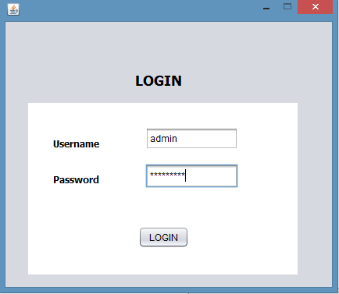

2.Software GUI with all menu and items

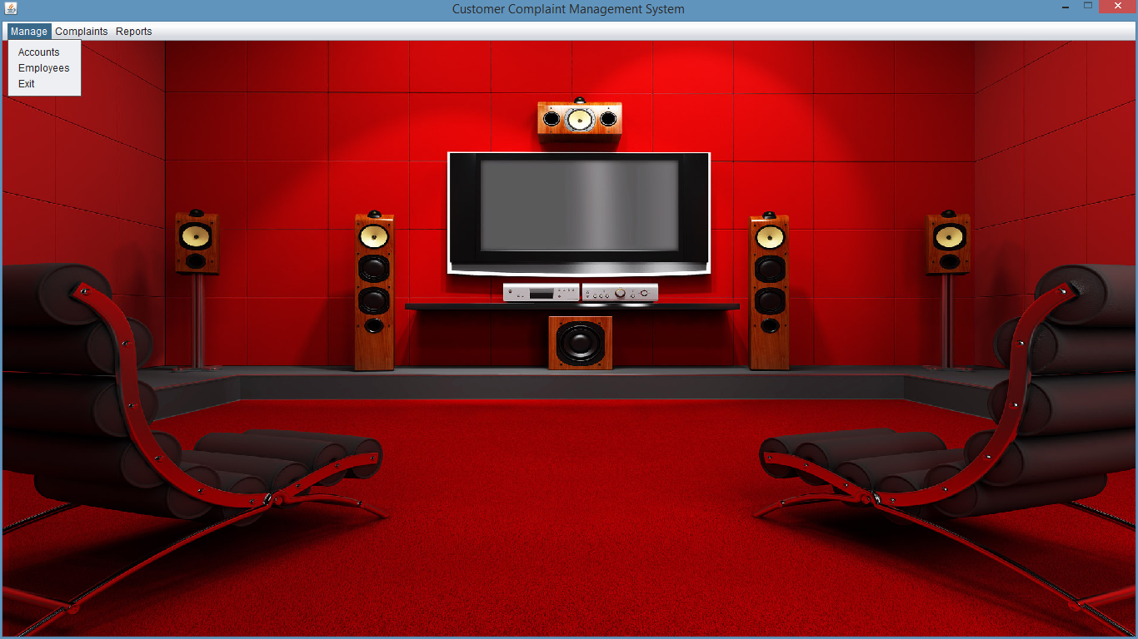

1. Account Module - Here we enter the information of the client and then all the information regarding all the customers is displayed in table below.

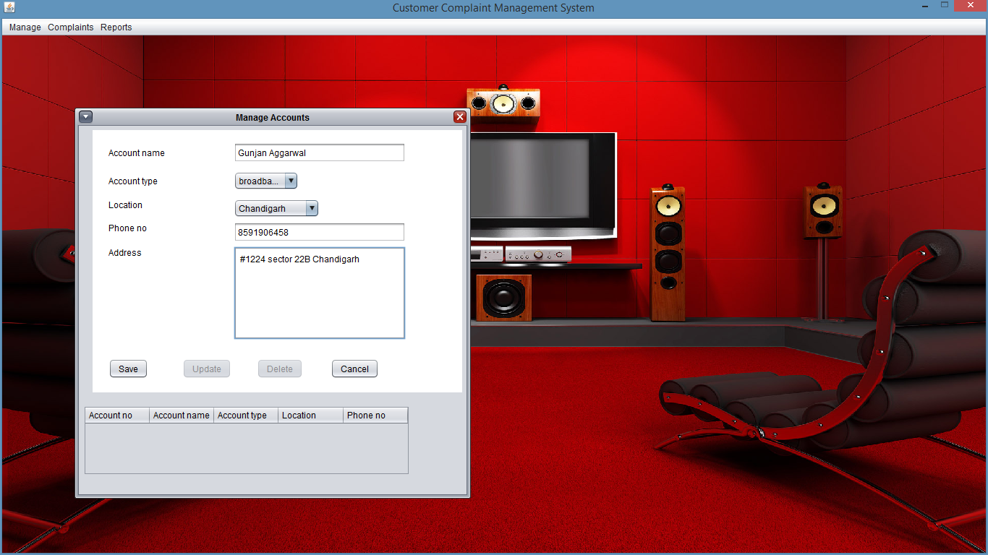

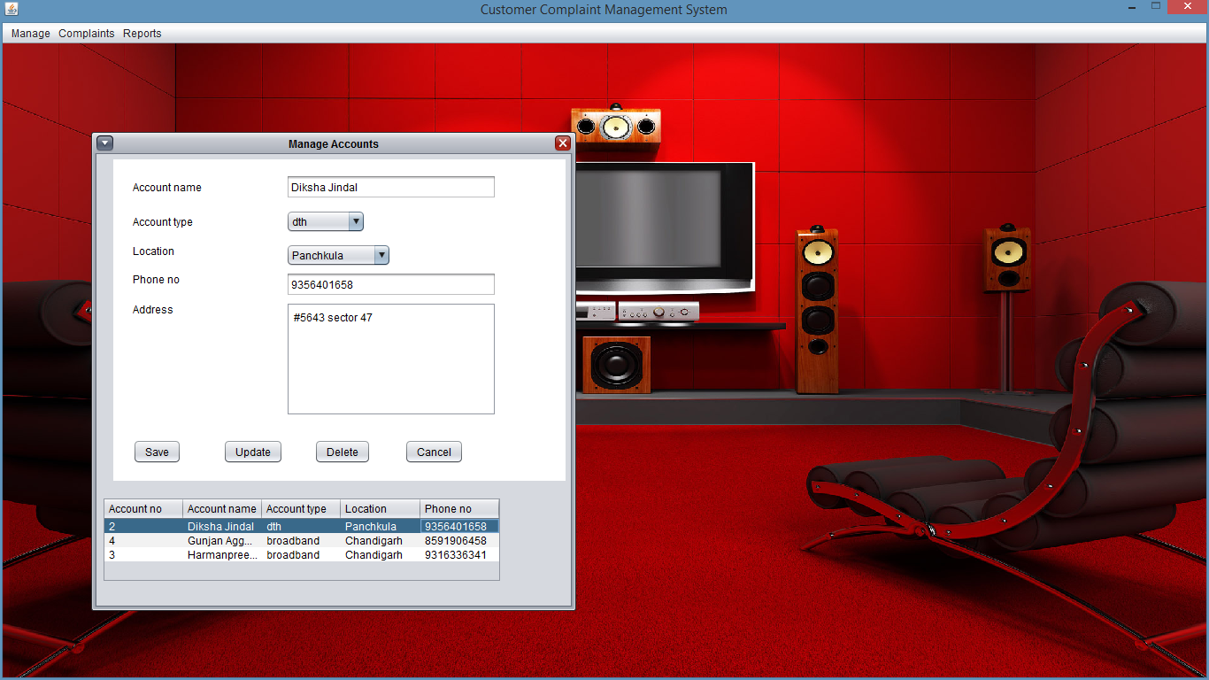

4. Employee Module- Where all information of every employee is stored in database and displayed in the table shown below.

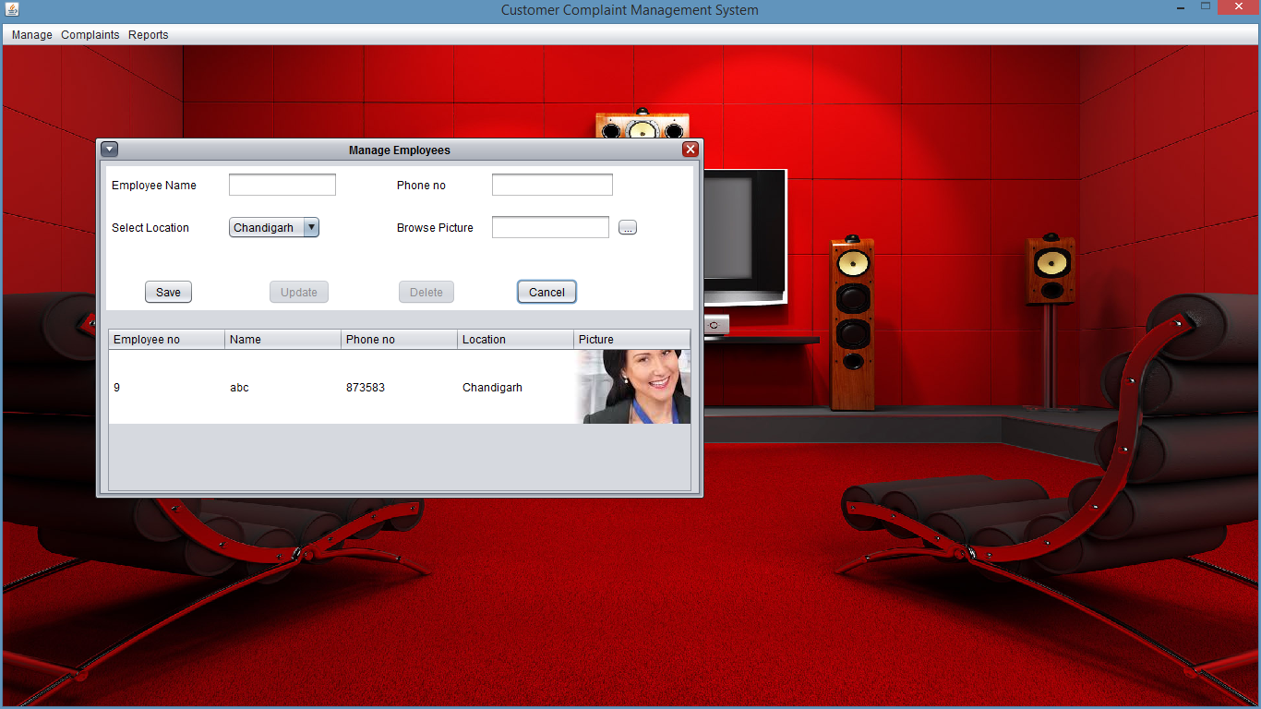

5.Registering Complaints- Client can issue complaints and issues uniquely identified by their account number and then services and employees are allotted

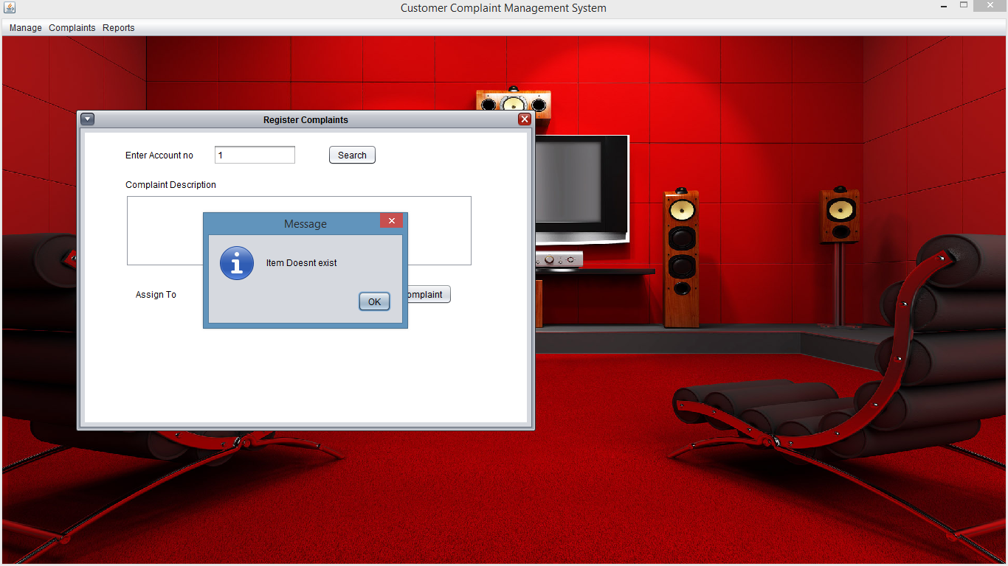

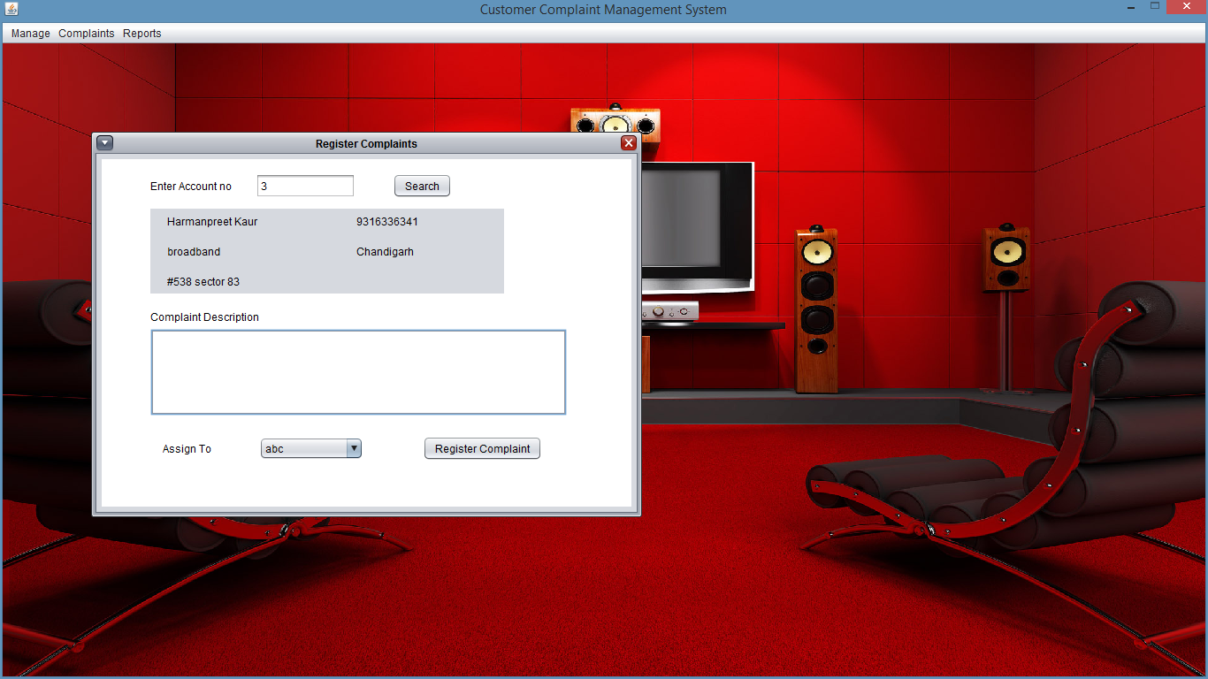

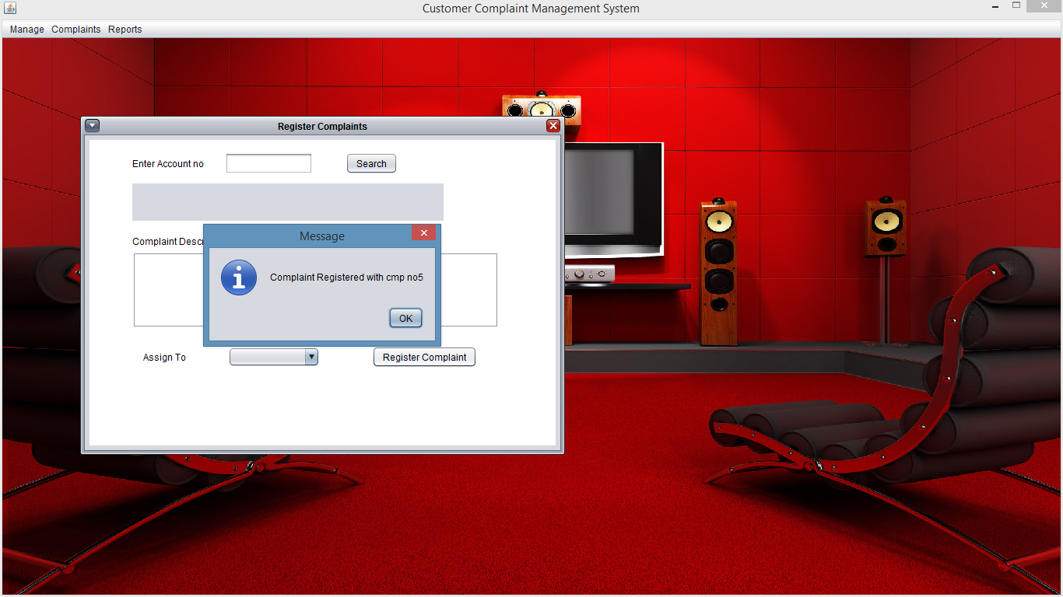

6.Complaint Feedback-Once the issue is resolved client can give the feedback depending the service he gets.

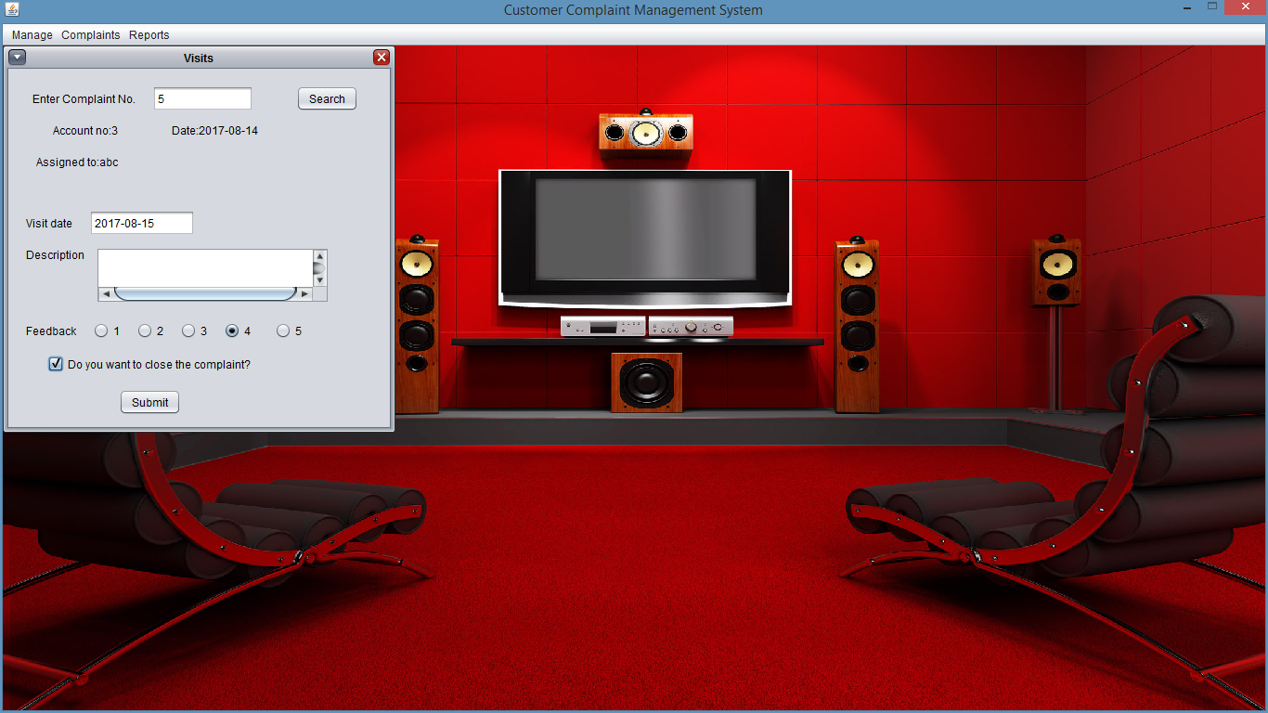

7. Maintaining Reports

1.Complaints in Current Month

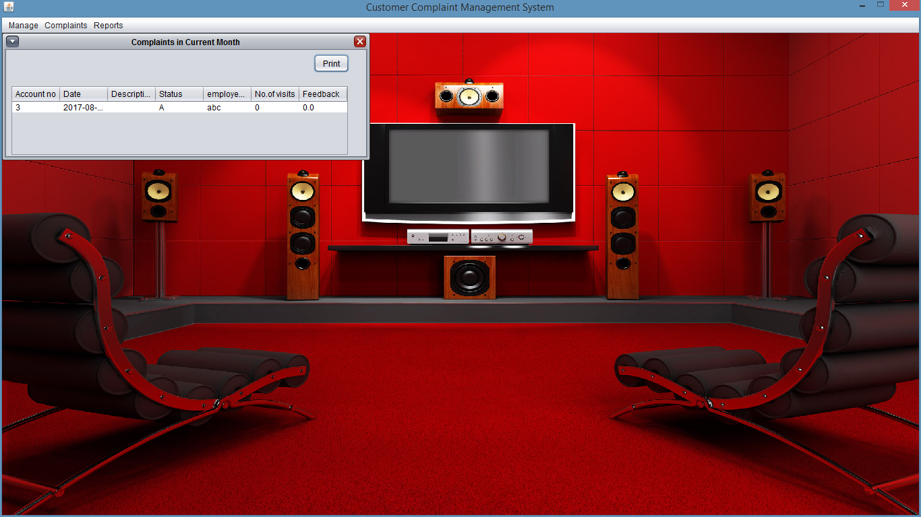

2.Complaints Handled by any Employee

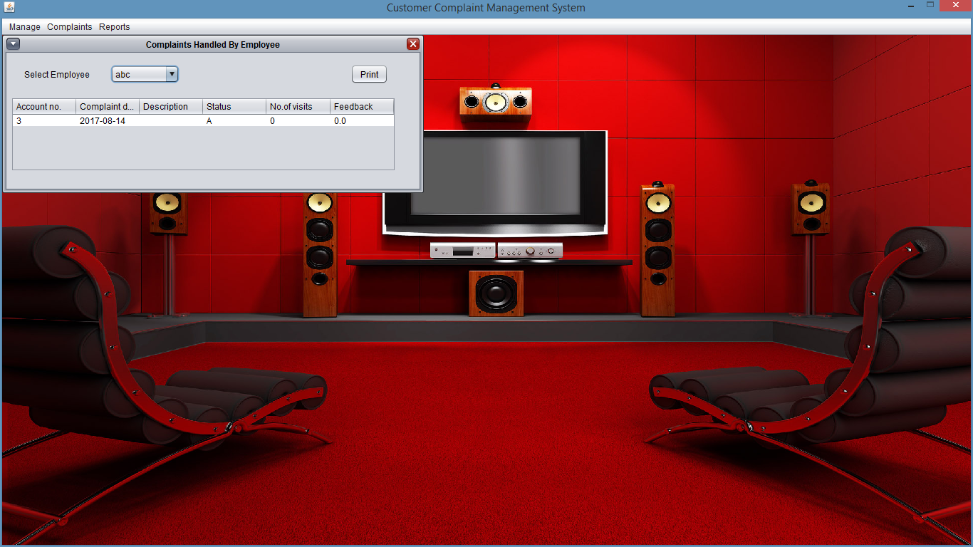

3.Overall Performance

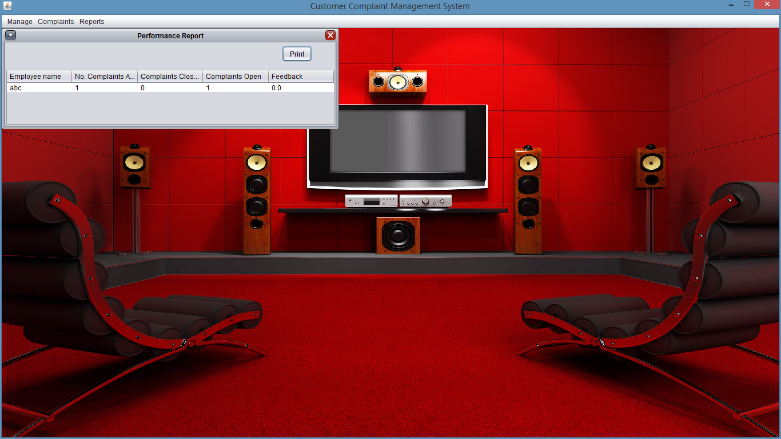

**TESTING AND DEBUGGING**

# INTRODUCTION:-

The implementation phase of software development is concerned with translating design specification into source code. The preliminary goal of implementation is to write source code and internal documentation so that conformance of the code to its specifications can be easily verified, and so that debugging, testing and modifications are eased. This goal can be achieved by making the source code as clear and straightforward as possible. Simplicity, clarity and elegance are the hallmark of good programs, obscurity, cleverness, and complexity are indications of inadequate design and misdirected thinking.

Source code clarity is enhanced by structured coding techniques, by good coding style, by, appropriate supporting documents, by good internal comments, and by feature provided in modern programming languages.

The implementation team should be provided with a well-defined set of software requirement, an architectural design specification, and a detailed design description. Each team member must understand the objectives of implementation.

TERMS IN TESTING FUNDAMENTAL

**1. Error**

The term error is used in two ways. It refers to the difference between the actual output of software and the correct output, in this interpretation, error is essential a measure of the difference between actual and ideal. Error is also to used to refer to human action that result in software containing a defect or fault.

**2. Fault**

Fault is a condition that causes to fail in performing its required function. A fault is a basic reason for software malfunction and is synonymous with the commonly used term Bug.

**3. Failure**

Failure is the inability of a system or component to perform a required function according to its specifications. A software failure occurs if the behavior of the software is the different from the specified behavior. Failure may be caused due to functional or performance reasons.

**a. Unit Testing**

The term unit testing comprises the sets of tests performed by an individual programmer prior to integration of the unit into a larger system.

A program unit is usually small enough that the programmer who developed it can test it in great detail, and certainly in greater detail than will be possible when the unit is integrated into an evolving software product. In the unit testing the programs are tested separately, independent of each other. Since the check is done at the program level, it is also called program teasing.

**b. Module Testing**

A module and encapsulates related component. So can be tested without other system module.

**c. Subsystem Testing**

Subsystem testing may be independently design and implemented common problems are sub-system interface mistake in this checking we concentrate on it.

There are four categories of tests that a programmer will typically perform on a program unit.

1. Functional test
2. Performance test
3. Stress test
4. Structure test

**1) Functional Test**

Functional test cases involve exercising the code with Nominal input values for which expected results are known; as well as boundary values (minimum values, maximum values and values on and just outside the functional boundaries) and special values.

**2) Performance Test**

Performance testing determines the amount of execution time spent in various parts of the unit, program throughput, response time, and device utilization by the program unit. A certain amount of avoid expending too much effort on fine-tuning of a program unit that contributes little to the over all performance of the entire system. Performance testing is most productive at the subsystem and system levels.

**3) Stress Test**

Stress test are those designed to intentionally break the unit. A great deal can be learned about the strengths and limitations of a program by examining the manner in which a program unit breaks.

**4)** **Structure Test**

Structure tests are concerned with exercising the internal logic of a program and traversing particular execution paths. Some authors refer collectively to functional performance and stress testing as “black box” testing. While structure testing is referred to as “white box” or “glass box” testing. The major activities in structural testing are deciding which path to exercise, deriving test date to exercise those paths, determining the test coverage criterion to be used, executing the test, and measuring the test coverage achieved when the test cases are exercised.

**DEBUGGING**

Defect testing is intended to find areas where the program does not confirm to its specifications. Tests are designed to reveal the presence of defect in the system.When defect have been found in the program. There must be discovered and removed. This is called “Debugging”.

**CONCLUSION :**

So Complaint Management System helps telecommunication companies in maintaining the database of all its customers and employees in a secure and more easy to use format as compared to old file system. In a fraction of second all records can be accessed and complaints are solved depending on the location of the employee and the problem. Reports are automatically generated which helps to see how successful the system is, to see overall performance of the company as well its employees.

**BIBLIOGRAPHY :**

## From Internet -:

* + Netbeans.org
  + Stackoverflow.com
  + Nab.co.au
  + Youtube.com

## From Text Books -:

* The Complete Reference(Java)-Herbert Schildt
* SQL,PL/SQL-The Programming language of Oracle(Evan Bayross)